Mohana Sundari S
Senior BIM Architect
Property
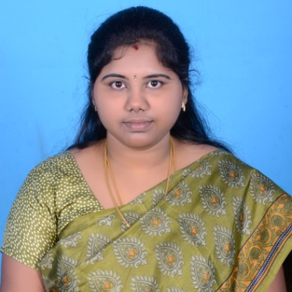
(Image should be square)
Profile |  | Key experience |  | Profession
Design Architect and BIM specialist, with over 5 years’ experience in Architecture and Retail industry. Hands-on experience in BIM implementation in Architecture field, with good knowledge and wide experience of global best practices. Have good knowledge of BIM processes, and in UK and Thai Retail standards. Proven track record of successfully implementing BIM based Retail designing and detailing. Mohana Sundari has done Graduation in Architecture from Adhiyamaan College of Engineering under Anna University. A certified Architect from the Council of Architecture (COA). |  | - BIM – Architecture  - CAD, MSTN, Photoshop and InDesign Software’s  - Retail Store designing  - Interior Designing  - Architectural Detailing |  | Senior BIM Architect
 |  |  |  | Joined Atkins
 |  |  |  | June 2015
 |  |  |  | Nationality / Languages
Indian
English, Kannada and Tamil
 |  |  |  | Qualifications
 |  |  |  | Bachelors in Architecture(B.Arch) from Adhiyamaan College of Engineering, Anna Unna University
 |  |  |  | Professional associations
 |  |  |  | Registered and Certified Architect from Council of Architecture.
Experience with Atkins (July 2015 – Till date)
Job Title: Senior BIM Architect
- Coordinating the Riyadh Metro team for BIM solutions.

Experience with Tesco, Bangalore (Nov 14 – June 15)
Job title: Design Architect
- Creation of the BIM models of all the signed off store plans in Revit.
- Preparation of GA and detail drawings in Revit.
- Creation of customised Family gallery for the equipment and fixture of the stores and maintaining it to up to date.
- Extraction of BOM and BOQ using Revit and Co-ordinating with the Costing team for the final output.
- Co coordinating with MEP team for a clash free model in BIM.
- Creating a catalogue for the all the standard fixtures of the stores in InDesign software.
- Preparing Permit drawings following the Thai standards in Co-ordination with Thai Contractors and submitting them to Thai Government.

- Experience with Tesco, Bangalore (Nov 14 – June 15)
Job title: Retail Planner
- Designing the UK – Tesco Retail stores
- Preparing store plans in line with pre-agreed standards and requirements specific to different countries.(UK, Thailand, India)
- Preparing the elevation pack, create drawings, update the Retail and building plan based on inputs received.
- Create optimal as-built plans using CAD applications (MSTN/ AutoCAD) and upload them on My Property (Corporate Portal).
- Co coordinating with UK colleagues and accountable for delivering operational KPIs, quality and timeline targets; Ensuring high quality store format plans as per business needs

Experience with Cube9 Architects, Bangalore (Aug 11 – June 11)
Job title: Junior Architect
- Designing residences and supporting the Senior Architect.
- Co-ordinating with contractors for the execution of designs on the site.
- Visiting sites to inspect the construction and solving issues on site.
- Designing interiors of residences and preparing detail drawings for the same.

